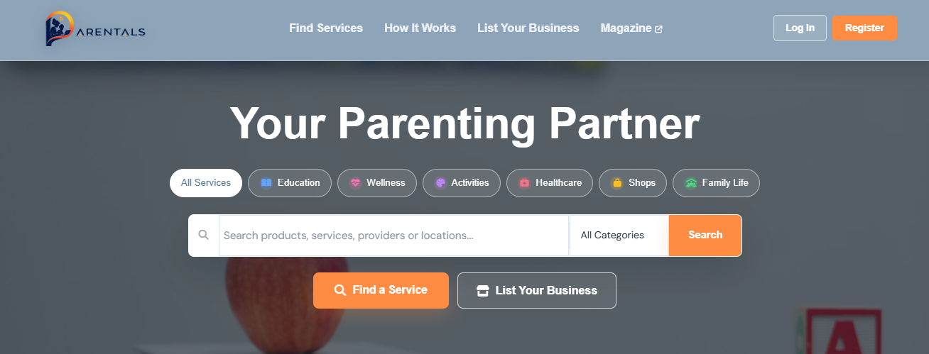

THE PARENTALS DETAILED DOCUMENTATION

Table of content
Chapter 1 — Introduction
1.1 Project Background
1.2 Problem Statement
1.3 Project Objectives
1.4 Project Scope
1.5 Target Users
1.6 Project Benefits
Chapter 2 — System Requirements and Analysis
2.1 Stakeholder Analysis
2.2 User Roles
2.3 Functional Requirements
2.4 Non-Functional Requirements
2.5 User Requirements
2.6 System Requirements
2.7 Use Cases
2.8 User Workflows
Chapter 3 — System Design
3.1 System Design Overview
3.2 Frontend Design
3.3 Backend Design
3.4 Admin Dashboard Design
3.5 Provider Dashboard Design
3.6 Public Directory Design
3.7 Authentication and Authorisation
3.8 User Interface and Responsive Design
Chapter 4 — Frontend Development
4.1 Frontend Technology Stack
4.2 React and Vite Architecture
4.3 Frontend Project Structure
4.4 Components and Pages
4.5 Navigation and Routing
4.6 User Registration and Login
4.7 Public Directory
4.8 Provider Dashboard
4.9 Admin Dashboard
4.10 Forms and Validation
4.11 Responsive Design
Chapter 5 — Backend Development
5.1 Backend Technology Stack
5.2 Node.js and Express Architecture
5.3 Backend Project Structure
5.4 REST API
5.5 Authentication and Authorisation
5.6 User and Provider Management
5.7 Booking Management
5.8 Admin Functionality
5.9 File Uploads
5.10 Error Handling and Validation
5.11 Security
Chapter 6 — System Functionality and Testing
6.1 User Registration and Login
6.2 Provider Registration and Verification
6.3 Provider Profiles and Services
6.4 Public Directory
6.5 Booking Functionality
6.6 Admin Management
6.7 Document Uploads
6.8 Dashboard Functionality
6.9 Functional Testing
6.10 Integration and UI Testing
6.11 Testing Results
Chapter 7 — Database Design
7.1 Database Technology
7.2 Database Architecture
7.3 Entity Relationship Design
7.4 Database Entities
7.5 Relationships and Constraints
7.6 Prisma ORM
7.7 Database Migrations and Seeding
7.8 Database Security
Chapter 8 — System Architecture
8.1 Overall System Architecture
8.2 Frontend Architecture
8.3 Backend Architecture
8.4 Database Architecture
8.5 Authentication Architecture
8.6 Provider Registration Flow
8.7 Public Directory Flow
8.8 Booking Architecture
8.9 Admin Architecture
8.10 Complete System Flow Diagram
8.11 External Services and Integrations

THE PARENTALS
Software Technical Documentation
Version: 1.0
Project Name: The Parentals
Application Type: Full-Stack Web Application
Technology Stack: React, Node.js, Express.js, PostgreSQL, Prisma ORM, JWT Authentication, Google OAuth, Paystack.

Chapter 1: Introduction
1.1 Background
Finding trustworthy parenting and homeschooling services can often be a difficult and time-consuming process. Parents frequently rely on recommendations from friends, social media groups, or internet searches, which do not always provide reliable or verified information. Likewise, many qualified service providers struggle to reach the right audience due to the absence of a dedicated platform that caters specifically to families seeking educational and parenting support.
The Parentals was developed to solve this problem by creating a centralized online platform where parents can easily discover verified service providers while enabling providers to professionally showcase their services. Instead of searching across multiple websites or relying on informal recommendations, users can access a single platform that brings together various parenting and homeschooling services in one secure environment.
The platform is designed to improve accessibility, trust, and convenience by providing a structured directory of providers, secure user authentication, provider verification, subscription management, and administrative oversight. By combining these features into one system, The Parentals aims to simplify the process of connecting families with professionals who can support children's educational and developmental needs.

1.2 Purpose of the System
The primary purpose of The Parentals is to provide a secure, scalable, and user-friendly digital platform that connects parents with trusted service providers specializing in parenting, homeschooling, education, therapy, tutoring, and other child-development services.
The platform serves three key groups of users:
- Parents and guardians looking for reliable educational and parenting services.
- Service providers who wish to market and manage their professional services online.
- System administrators responsible for maintaining platform quality, approving providers, monitoring activity, and managing system operations.
By bringing these users together within a single web application, The Parentals reduces the challenges associated with finding trustworthy services while creating opportunities for providers to grow their businesses.

1.3 Problem Statement
Parents often face several challenges when searching for educational or parenting-related services. Information is frequently scattered across different websites, social media platforms, and community groups, making it difficult to compare providers or verify their qualifications. In many cases, parents must rely solely on personal recommendations, which may not always be available or objective.
Service providers encounter similar challenges. Although they may possess valuable skills and qualifications, reaching potential clients can be difficult without a dedicated platform designed specifically for parenting and educational services. Marketing through general advertising channels can be costly and ineffective, especially for smaller businesses or independent professionals.
These challenges highlight the need for a centralized system that allows providers to present their qualifications professionally while giving parents confidence that they are engaging with verified professionals.

1.4 Proposed Solution
The Parentals addresses these challenges by providing a web-based platform that allows service providers to create comprehensive professional profiles while enabling parents to browse, search, and evaluate available services.
The system incorporates several integrated features, including secure user registration, role-based authentication, provider verification, profile management, subscription payments, review management, and administrative controls. These features work together to create a reliable ecosystem where users can interact with confidence.
By digitizing the provider registration and discovery process, The Parentals significantly reduces the effort required for parents to find appropriate services while simultaneously giving providers increased visibility within their target market.

1.5 Project Objectives
The primary objective of The Parentals is to simplify the process of connecting parents with qualified educational and parenting service providers through an intuitive digital platform.
Specific objectives include:
- Develop a secure online platform that allows users to register and authenticate using email/password or Google Sign-In.
- Create a searchable directory of verified parenting and educational service providers.
- Enable providers to build detailed professional profiles that include qualifications, services, pricing, and supporting documentation.
- Implement secure role-based access control to ensure users only access features appropriate to their roles.
- Integrate an online payment system that allows providers to purchase subscription plans securely.
- Provide administrators with tools to monitor platform activity, approve providers, manage reviews, and oversee system operations.
- Ensure the platform is scalable, maintainable, and capable of supporting future enhancements.

1.6 Scope of the Project
The scope of The Parentals includes the development of a full-stack web application consisting of a React-based frontend, a Node.js and Express backend, and a PostgreSQL database managed through Prisma ORM.
The project includes the following major functional areas:
- User registration and authentication.
- Google OAuth integration.
- Provider registration and profile management.
- Parent account management.
- Administrative dashboard.
- Review and moderation system.
- Subscription payment processing through Paystack.
- Featured provider listings.
- Secure database management.
- Responsive web interface.
The current scope does not include real-time messaging, mobile applications, appointment scheduling, or video conferencing. These features have been identified as potential future enhancements.

1.7 Target Users
The Parentals has been designed to support three primary categories of users.

Parents
Parents and guardians use the platform to discover educational and parenting services that meet their specific needs. They can browse provider profiles, compare available services, and identify qualified professionals within a secure environment.
Service Providers
Service providers use the platform to advertise their businesses, manage their professional profiles, upload supporting documentation, and reach a wider audience of parents seeking specialized services.
Administrators
Administrators oversee the operation of the platform. Their responsibilities include approving provider applications, managing user accounts, moderating reviews, monitoring payment records, and ensuring that the platform maintains high standards of quality and security.

1.8 Benefits of the System
The Parentals offers significant benefits to all stakeholders involved.
For parents, the platform simplifies the process of locating trusted service providers while reducing uncertainty through verified provider profiles and structured information.
For service providers, the platform offers increased visibility, improved marketing opportunities, and a centralized location for managing professional information and subscriptions.
For administrators, the platform streamlines provider management, enhances oversight, and simplifies monitoring through centralized dashboards and automated workflows.
Overall, the system contributes to a more organized, transparent, and efficient ecosystem for parenting and educational services.

1.9 Document Overview
This document provides a comprehensive technical description of The Parentals system. It explains the project's objectives, architecture, technologies, database design, authentication mechanisms, payment integration, system workflows, deployment process, and future development opportunities.
The documentation is intended to serve as both a technical reference for developers and a comprehensive overview for stakeholders interested in understanding the system's design and functionality.

Chapter 2: System Overview
2.1 Introduction
The Parentals is a full-stack web application developed to provide a centralized digital platform that connects parents with qualified educational and parenting service providers. The application simplifies the process of discovering, registering, and managing parenting services by offering secure authentication, provider verification, subscription management, and administrative oversight.
The system is designed using a modern three-tier architecture consisting of a presentation layer (frontend), an application layer (backend), and a data layer (database). This architecture ensures that the system remains scalable, maintainable, and secure while supporting future enhancements.
Unlike traditional directories or social media groups where information may be unstructured or difficult to verify, The Parentals provides a professional environment where service providers can showcase their qualifications and parents can confidently search for trusted services.

2.2 System Description
The Parentals functions as an online marketplace specifically designed for parenting and educational services. The platform enables different categories of users to interact through a secure web-based environment while ensuring that each user only has access to features relevant to their role.
The application allows parents to browse provider profiles, compare available services, and identify professionals that best meet their needs. Service providers are able to register their businesses, upload qualifications and supporting documents, subscribe to platform plans, and manage their professional profiles. Administrators oversee all platform operations, ensuring that provider information is verified and that the overall quality of the platform is maintained.
Every interaction within the system is processed through secure backend APIs that communicate with a PostgreSQL database using Prisma ORM. Authentication is handled through JSON Web Tokens (JWT), while Google OAuth provides users with an alternative login method.

2.3 System Goals
The Parentals was developed with several key goals in mind.
The first goal is to simplify access to parenting and educational services by providing a centralized directory of qualified professionals.
The second goal is to improve trust by implementing a provider approval process that ensures only verified providers appear on the platform.
Another important goal is to provide service providers with an affordable and professional platform where they can promote their services, manage their business information, and reach a larger audience.
The system also aims to automate administrative processes such as provider approvals, review moderation, payment verification, and subscription management, reducing manual effort while improving operational efficiency.
Finally, the platform has been designed with scalability in mind, allowing additional services such as appointment scheduling, messaging, mobile applications, and AI-powered recommendations to be introduced in future versions.

2.4 Major System Modules
The Parentals is divided into several major modules, each responsible for a specific area of functionality.
User Management Module
The User Management Module is responsible for creating and maintaining user accounts. It allows new users to register, existing users to log in securely, and authenticated users to manage their account information.
This module supports both traditional email/password authentication and Google Sign-In through OAuth.
Key responsibilities include:
- User registration
- Login
- Password encryption
- JWT generation
- Google authentication
- Role management
- Session validation

Provider Management Module
The Provider Management Module enables service providers to create detailed professional profiles that showcase their qualifications and services.
Providers are required to submit business information, upload supporting documentation, select service categories, and choose subscription plans before their profiles become publicly available.
This module allows providers to:
- Create provider profiles
- Update business information
- Upload certificates
- Upload profile photographs
- Manage pricing
- Update service availability
- Select subscription plans
- View subscription status

Parent Module
The Parent Module provides users with the ability to search for providers and view detailed provider profiles.
Parents can compare services, read reviews, and access important provider information before making decisions.
The Parent Module focuses primarily on improving accessibility and simplifying the process of discovering reliable parenting services.

Administration Module
The Administration Module provides complete control over the platform.
Administrators are responsible for monitoring activity across the application and ensuring that all providers meet the platform's standards before becoming publicly visible.
Administrative responsibilities include:
- Approving provider registrations
- Rejecting incomplete applications
- Managing users
- Managing reviews
- Viewing platform statistics
- Managing featured providers
- Monitoring payment transactions
The administration dashboard provides centralized access to these management tools through a secure interface.

Payment Module
The Payment Module manages subscription payments for service providers.
When providers choose a subscription plan, payment requests are securely processed through Paystack. Once payment has been successfully verified, the provider's subscription is activated and recorded within the system.
The Payment Module is responsible for:
- Subscription payments
- Payment verification
- Transaction history
- Payment status updates
- Subscription activation

Review Management Module
The Review Management Module allows clients to provide feedback on providers after using their services.
Reviews improve transparency and help future users make informed decisions.
To maintain quality, administrators can moderate reviews before they become publicly visible.
This module manages:
- Customer ratings
- Written reviews
- Review moderation
- Review approval
- Review removal

2.5 User Roles
The Parentals uses Role-Based Access Control (RBAC) to ensure that each user only has access to features relevant to their responsibilities.
There are three primary user roles within the system.
User Role | Description
Parent/User | Searches providers, views profiles, and manages their personal account.
Provider | Creates and manages a professional profile, uploads documentation, and manages subscriptions.
Administrator | Oversees the entire platform, approves providers, manages users, reviews, payments, and platform statistics.
Each role is protected by authentication middleware that verifies the user's permissions before granting access to restricted resources.

2.6 System Workflow
The overall workflow of The Parentals can be summarized as follows:
User Visits Website
│
▼
Create Account / Login
│
┌───────────────┴───────────────┐
│ │
▼ ▼
Parent/User Provider
│ │
▼ ▼
Browse Providers Register Business
│ │
▼ ▼
View Profiles Upload Documents
│ │
▼ ▼
Choose Service Administrator Review
│
▼
Provider Approved
│
▼
Subscription Payment
│
▼
Provider Profile Published
This workflow illustrates the interaction between the primary users and the main processes within the platform.

2.7 System Advantages
The Parentals offers several advantages over traditional methods of finding parenting services.
Firstly, the platform centralizes information, eliminating the need for parents to search across multiple websites or social media platforms.
Secondly, provider verification improves trust by ensuring that only approved providers are publicly visible.
Thirdly, the integration of secure authentication and online payment systems enhances user confidence while simplifying subscription management.
Finally, the modular architecture adopted by the system allows developers to introduce new features with minimal impact on existing functionality, making the platform highly maintainable and scalable.

2.8 Summary
The Parentals is a comprehensive digital platform designed to simplify the relationship between parents and educational service providers. Through its modular architecture, secure authentication mechanisms, provider management features, and administrative oversight, the system delivers a reliable and user-friendly environment for all stakeholders.
The separation of responsibilities across the various modules ensures that the platform remains organized, secure, and capable of supporting future enhancements without requiring major architectural changes.

Chapter 3: System Features and Functional Requirements
3.1 Introduction
This chapter describes the core features and functional requirements of The Parentals system. Functional requirements define the specific operations that the system must perform to meet the needs of its users. These requirements outline the expected behaviour of the application, the interactions between users and the system, and the services provided by each module.
In addition to functional requirements, this chapter also discusses the non-functional requirements that ensure the system remains secure, reliable, scalable, and user-friendly. Together, these requirements establish the foundation upon which the application has been designed and developed.

3.2 Functional Requirements
Functional requirements describe the actions and services that the application must provide. Every feature implemented within The Parentals contributes towards fulfilling one or more of these requirements.

3.2.1 User Registration
The system shall allow new users to create an account using either an email address and password or Google Sign-In. During registration, users are required to provide accurate personal information, including their name and email address.
Once registration is complete, the system stores the user's information securely in the PostgreSQL database. Passwords are encrypted using bcrypt before being saved to ensure user credentials remain protected.
The registration process ensures that duplicate email addresses cannot be used and that all required information is validated before the account is created.
Requirements:
- The system shall allow new users to register.
- The system shall validate all required fields.
- The system shall prevent duplicate email registrations.
- The system shall encrypt user passwords before storage.
- The system shall assign a default user role upon successful registration.

3.2.2 User Authentication
The Parentals implements secure authentication using JSON Web Tokens (JWT). Registered users can log into the platform using their credentials or by authenticating with their Google account.
After successful authentication, the backend generates a JWT token which is returned to the frontend. This token is stored securely and attached to future API requests, allowing protected resources to verify the identity of the requesting user.
Authentication ensures that only authorized users can access restricted functionality.
Requirements:
- The system shall authenticate registered users.
- The system shall generate JWT tokens upon successful login.
- The system shall verify JWT tokens for protected API endpoints.
- The system shall deny access to unauthorized users.
- The system shall support Google OAuth authentication.

3.2.3 Provider Registration
Service providers must complete a registration process before becoming visible on the platform. This process requires providers to submit detailed business information, upload supporting documentation, and select appropriate service categories.
Once submitted, provider applications remain in a pending state until reviewed by an administrator. Only approved providers become publicly visible.
This verification process helps maintain the credibility and quality of services listed on the platform.
Requirements:
- The system shall allow providers to create professional profiles.
- The system shall allow providers to upload supporting documents.
- The system shall record provider qualifications.
- The system shall allow providers to select service categories.
- The system shall mark new provider applications as pending.
- The system shall notify administrators of new applications.

3.2.4 Provider Profile Management
Approved providers can manage their professional information through a dedicated dashboard. Providers may update their biographies, pricing, services, availability, qualifications, and profile photographs at any time.
Changes made to provider profiles are stored in the database and reflected on the public directory.

Requirements:
- The system shall allow providers to edit their profiles.
- The system shall allow profile photo uploads.
- The system shall store business information.
- The system shall maintain provider availability.
- The system shall update provider details without affecting other users.

3.2.5 Provider Search
Parents can browse and search available providers using the public directory. The search functionality enables users to locate providers based on service categories and available information.
Each provider profile displays detailed information, including qualifications, pricing, biography, reviews, and other relevant details.
This feature simplifies the process of finding suitable educational and parenting services.
Requirements:
- The system shall display approved providers.
- The system shall allow provider searches.
- The system shall display detailed provider profiles.
- The system shall hide unapproved providers.

3.2.6 Review Management
Parents can provide ratings and written reviews after interacting with providers. Reviews contribute to provider credibility while helping future users make informed decisions.
To maintain platform quality, administrators have the authority to moderate reviews before publication.
Requirements:
- The system shall allow users to submit reviews.
- The system shall allow users to assign ratings.
- The system shall display approved reviews.
- The system shall allow administrators to remove inappropriate reviews.

3.2.7 Subscription Management
The Parentals operates using subscription plans for service providers. Providers must select a subscription package before their listings become active.
Subscription information is recorded within the database and linked to payment transactions.
Requirements:
- The system shall display available subscription plans.
- The system shall activate subscriptions after successful payment.
- The system shall store subscription information.
- The system shall maintain payment history.

3.2.8 Payment Processing
Subscription payments are processed using Paystack.
When a provider selects a subscription plan, the frontend communicates with the backend, which initializes a secure payment session through Paystack. Once payment has been verified, the transaction is recorded and the provider's subscription status is updated.
This process ensures that payment information remains secure while providing accurate transaction records.
Requirements:
- The system shall integrate with Paystack.
- The system shall verify successful payments.
- The system shall record payment transactions.
- The system shall update provider subscription status.

3.2.9 Administration
The Administration Module allows platform administrators to manage all major aspects of the application. Administrators can approve providers, monitor users, moderate reviews, and review payment information.
The administrator dashboard provides statistical summaries that assist in monitoring overall platform activity.
Requirements:
- The system shall provide an administrator dashboard.
- The system shall allow provider approval and rejection.
- The system shall display platform statistics.
- The system shall allow review moderation.
- The system shall allow payment monitoring.

3.3 Non-Functional Requirements
Non-functional requirements define the quality attributes that the system must satisfy.

Performance
The application should respond quickly to user requests and efficiently handle multiple users simultaneously. Database queries should be optimized to minimise loading times and improve the overall user experience.

Reliability
The Parentals should provide consistent and dependable operation. User information, provider data, and payment records must remain accurate and available whenever the system is operational.

Security
Security is one of the most important requirements of the system.
The application protects user data through password hashing, secure authentication, role-based authorization, and environment variables for sensitive configuration.
Only authenticated users are allowed to access protected resources, while administrators have additional permissions for system management.

Scalability
The modular architecture adopted by The Parentals enables future expansion without requiring major modifications to the existing codebase.
Additional modules such as appointment scheduling, messaging, and mobile applications can be integrated with minimal disruption.

Maintainability
The system has been structured using a modular architecture that separates frontend components, backend controllers, database models, and business logic.
This organization improves code readability, simplifies debugging, and supports future maintenance.

Usability
The Parentals provides an intuitive user interface that enables users with limited technical knowledge to navigate the application easily.
Clear navigation, responsive layouts, and structured forms contribute to a positive user experience across desktop and mobile devices.

Compatibility
The application is designed to function correctly on modern web browsers such as Google Chrome, Microsoft Edge, Mozilla Firefox, and Safari.
Its responsive interface also ensures usability across various screen sizes.

3.4 Summary
The Parentals provides a comprehensive set of functional features that support parents, service providers, and administrators through a secure and scalable web platform. These features, combined with carefully defined non-functional requirements, ensure that the system delivers reliable performance, protects user data, and remains adaptable to future enhancements.
The functional requirements describe the services the application must perform, while the non-functional requirements establish the standards for quality, security, and usability. Together, they provide a clear specification for the development and continued evolution of the platform.

Chapter 4: System Architecture and Design
4.1 Introduction
System architecture refers to the overall structure of a software application and describes how its various components interact to deliver the required functionality. A well-designed architecture ensures that the application remains scalable, maintainable, secure, and efficient throughout its lifecycle.
The Parentals has been developed using a three-tier architecture, which separates the application into three distinct layers:
- Presentation Layer (Frontend)
- Application Layer (Backend)
- Data Layer (Database)
This separation of concerns allows each layer to perform a specific responsibility while communicating with the other layers through well-defined interfaces. The architecture improves maintainability, simplifies debugging, and allows future enhancements to be implemented with minimal impact on existing functionality.

4.2 Three-Tier Architecture
The Parentals follows the traditional three-tier software architecture commonly used in modern web applications.
The three layers work together to process user requests, execute business logic, and manage persistent data.
┌─────────────────────────────┐
│ Presentation │
│ React + Vite Frontend │
└──────────────┬─────────────┘
│
HTTP / REST API
│
┌──────────────▼──────────────┐
│ Application Layer │
│ Node.js + Express API │
└──────────────┬──────────────┘
│
Prisma ORM
│
┌──────────────▼─────────────┐
│ Data Layer │
│ PostgreSQL Database Server │
└─────────────────────────────┘
The presentation layer communicates with the backend using RESTful API requests. The backend processes these requests, applies business logic, and communicates with the PostgreSQL database using Prisma ORM. Responses are then returned to the frontend for display to the user.

4.3 Presentation Layer (Frontend)
The presentation layer is responsible for everything that users see and interact with in their web browser. It provides the graphical user interface (GUI) and allows users to communicate with the backend system.
The Parentals frontend was developed using React.js together with Vite, providing a modern and responsive single-page application (SPA). React was selected because it supports reusable components, improves performance through the Virtual DOM, and simplifies the development of dynamic user interfaces.
The frontend manages user interactions such as registration, login, searching for providers, viewing profiles, submitting forms, and navigating between pages. Instead of communicating directly with the database, it sends HTTP requests to the backend API and displays the responses received.
Responsibilities of the Frontend
The frontend is responsible for:
- Displaying all pages and user interfaces.
- Collecting user input through forms.
- Performing client-side validation.
- Managing navigation between pages.
- Displaying provider information.
- Displaying dashboards.
- Sending API requests to the backend.
- Receiving and displaying API responses.
- Managing authentication tokens during active user sessions.

Major Frontend Components
The frontend consists of several key sections, each designed to support a different area of the application.
Component | Purpose
Home Page | Introduces the platform and allows users to browse services.
Login Page | Authenticates registered users.
Registration Page | Allows users and providers to create accounts.
Provider Dashboard | Enables providers to manage their profiles and subscriptions.
Client Dashboard | Allows parents to manage their accounts and view information.
Admin Dashboard | Provides administrative tools for managing the platform.
Profile Pages | Displays detailed provider information.
Navigation Components | Allows users to move between pages.

4.4 Application Layer (Backend)
The backend serves as the core processing unit of The Parentals. It receives requests from the frontend, validates the incoming data, executes business logic, communicates with the database, and returns appropriate responses.
The backend was developed using Node.js and Express.js, providing a lightweight and efficient environment for building RESTful APIs.
Unlike the frontend, the backend has direct access to the database and is responsible for enforcing security, validating permissions, processing payments, and maintaining data integrity.
Responsibilities of the Backend
The backend performs several important tasks:
- User authentication.
- User authorization.
- Provider management.
- Payment processing.
- Review management.
- File upload handling.
- Database communication.
- API response generation.
- Business rule enforcement.
Every request from the frontend passes through the backend before reaching the database.

Backend Architecture
The backend follows a modular architecture where different responsibilities are separated into dedicated files and folders.
Backend
│
├── Routes
│
│
▼
├── Controllers
│
│
▼
├── Middleware
│
│
▼
├── Prisma ORM
│
│
▼
└── PostgreSQL Database
This modular approach improves code organization and allows developers to maintain and extend the application more easily.

4.5 Data Layer (Database)
The data layer stores all information used by the application. It is responsible for maintaining persistent records of users, providers, reviews, payments, and other system data.
The Parentals uses PostgreSQL, an open-source relational database management system known for its reliability, scalability, and support for complex relationships.
Instead of writing raw SQL queries throughout the application, Prisma ORM provides a type-safe interface that simplifies database interactions.
Information Stored
The database stores:
- User accounts
- Provider profiles
- Authentication information
- Subscription records
- Payment transactions
- Reviews
- Featured listings
- Administrative data
The use of relational tables ensures that information remains organized and consistent.

4.6 API Communication
The frontend and backend communicate using RESTful APIs.
Whenever a user performs an action, such as logging in or updating a profile, the frontend sends an HTTP request to the backend.
The backend processes the request and returns a response in JSON format.
A simplified communication flow is shown below.
User
│
▼
Frontend (React)
│
│ HTTP Request
▼
Express API
│
▼
Business Logic
│
▼
Prisma ORM
│
▼
PostgreSQL
│
▲
JSON Response
│
▲
Frontend
│
▲
User
This communication model separates the user interface from the application logic, improving maintainability and scalability.

4.7 Authentication Architecture
Authentication ensures that only authorized users can access protected resources within the system.
The Parentals uses a combination of JWT (JSON Web Tokens) and Google OAuth.
The authentication process follows these steps:
- The user submits login credentials.
- The backend validates the credentials.
- If valid, a JWT is generated.
- The token is returned to the frontend.
- The frontend stores the token securely.
- Future API requests include the JWT.
- The backend verifies the token before granting access.

Login
│
▼
Validate Credentials
│
▼
Generate JWT
│
▼
Frontend Stores Token
│
▼
Protected API Requests
│
▼
Token Verification
│
▼
Access Granted
This architecture enables stateless authentication, reducing server-side session management while maintaining security.

4.8 Design Principles
Several software engineering principles guided the design of The Parentals.
Separation of Concerns
Each layer of the application has a clearly defined responsibility. The frontend focuses on presentation, the backend manages business logic, and the database handles persistent storage.
Modularity
The application is divided into independent modules, allowing developers to work on individual components without affecting the rest of the system.

Scalability
The architecture supports future growth by making it easy to introduce additional modules such as appointment scheduling, messaging, or mobile applications.
Maintainability
A structured folder organization, reusable components, and modular backend architecture simplify debugging, testing, and future maintenance.
Security
Sensitive operations such as authentication, authorization, and payment verification are handled on the server side to protect user information and system integrity.

4.9 Advantages of the Chosen Architecture
The three-tier architecture provides several important benefits:
- Clear separation between the user interface, business logic, and data storage.
- Easier maintenance due to modular design.
- Improved scalability for future features.
- Enhanced security by isolating the database from direct user access.
- Better performance through optimized communication between layers.
- Simplified testing and debugging.
These advantages make the architecture suitable for a growing platform such as The Parentals, where new functionality can be added without requiring significant changes to the existing codebase.

4.10 Summary
The Parentals has been designed using a modern three-tier architecture that promotes scalability, security, and maintainability. By separating the frontend, backend, and database into distinct layers, the system achieves a clear separation of responsibilities while supporting efficient communication between components.
The use of React, Node.js, Express.js, Prisma ORM, and PostgreSQL provides a robust technical foundation capable of supporting current requirements and future expansion. The modular architecture also enables developers to introduce new features with minimal impact on existing functionality, ensuring that the platform can continue to evolve as user needs change.

Chapter 5: Technology Stack
5.1 Introduction
The success of any software application depends not only on its functionality but also on the technologies used during its development. Selecting an appropriate technology stack is essential for building a system that is reliable, secure, maintainable, and scalable.
The Parentals was developed using modern web technologies that support full-stack application development. The project follows a client-server architecture, where the frontend is responsible for presenting information to users, the backend processes business logic, and the database manages persistent data.
Each technology was selected based on its strengths, compatibility with the project requirements, ease of maintenance, and support from the developer community.
The following sections explain each technology used in the development of The Parentals, its purpose within the application, and the reasons for its selection.

5.2 Overview of the Technology Stack
The Parentals uses the following technologies:
Technology | Purpose
React.js | Frontend user interface development
Vite | Frontend build tool and development server
HTML5 | Structure of web pages
CSS3 | Styling and responsive design
JavaScript (ES6+) | Application logic
Node.js | Backend runtime environment
Express.js | REST API development
PostgreSQL | Relational database
Prisma ORM | Database access and management
JWT | User authentication
Google OAuth | Social login
Paystack | Online payment processing
Git & GitHub | Version control and collaboration
npm | Package management
These technologies work together to deliver a modern, secure, and responsive web application.

5.3 Frontend Technologies
React.js
React.js was used to build the frontend of The Parentals. React is a JavaScript library that enables developers to create reusable user interface components and build dynamic single-page applications.
One of React's greatest strengths is its component-based architecture. Instead of repeating code across multiple pages, developers can create reusable components that can be shared throughout the application. This improves consistency and reduces development time.
Within The Parentals, React is responsible for displaying pages such as the homepage, registration forms, login screens, dashboards, provider profiles, and administrative interfaces.
Why React was chosen
React was selected because it offers several advantages:
- Component reusability.
- Faster rendering through the Virtual DOM.
- Easy maintenance.
- Strong community support.
- Excellent compatibility with REST APIs.
- Scalability for future enhancements.

Vite
Vite was used as the frontend build tool during development.
Unlike traditional build tools, Vite provides an extremely fast development environment by using native ES modules. This significantly reduces application startup time and allows developers to see changes instantly while coding through Hot Module Replacement (HMR).
Throughout the development of The Parentals, Vite improved productivity by reducing waiting times during development and simplifying the frontend build process.
Advantages of Vite
- Fast development server.
- Instant page refresh.
- Optimized production builds.
- Lightweight configuration.
- Excellent integration with React.

HTML5 and CSS3
HTML5 provides the structural layout of the application's pages, while CSS3 is responsible for styling, responsiveness, and visual presentation.
These technologies ensure that users experience a clean, professional, and responsive interface across different devices and screen sizes.
Responsive layouts allow users to access The Parentals from desktop computers, laptops, tablets, and mobile devices without compromising usability.

JavaScript (ES6+)
JavaScript serves as the primary programming language for the frontend.
It enables interactive features such as:
- Form validation.
- Dynamic page updates.
- Navigation.
- API communication.
- User interaction.
- Dashboard functionality.
Modern JavaScript features such as arrow functions, asynchronous programming using async/await, modules, and object destructuring contribute to cleaner and more maintainable code.

5.4 Backend Technologies
Node.js
Node.js provides the runtime environment for executing JavaScript on the server.
Instead of using different programming languages for the frontend and backend, Node.js allows the entire application to be developed using JavaScript.
This reduces development complexity while improving consistency across the project.
Within The Parentals, Node.js processes incoming requests, executes business logic, communicates with the database, and returns responses to the frontend.
Advantages of Node.js
- High performance.
- Non-blocking architecture.
- Event-driven programming model.
- Large ecosystem of packages.
- Excellent support for REST APIs.

Express.js
Express.js is the web framework used to develop the backend REST API.
Express simplifies routing, middleware management, authentication, and request handling.
Every request made from the frontend passes through Express before reaching the database.
Examples include:
- User registration.
- User login.
- Provider profile creation.
- Provider updates.
- Payment verification.
- Review management.
Express was selected because it is lightweight, flexible, and integrates seamlessly with Node.js.

5.5 Database Technologies
PostgreSQL
PostgreSQL is the relational database used by The Parentals.
It stores all persistent system data including:
- User accounts.
- Provider profiles.
- Reviews.
- Subscription information.
- Payment transactions.
- Featured listings.
PostgreSQL was chosen because it provides excellent reliability, strong data integrity, and support for complex relationships between tables.
Its ability to enforce constraints and maintain data consistency makes it well suited for applications handling user authentication and financial transactions.

Prisma ORM
Prisma ORM acts as the communication layer between the backend and PostgreSQL.
Instead of writing raw SQL queries, Prisma allows developers to interact with the database using a type-safe API.
Prisma was used throughout the project to:
- Create database models.
- Execute queries.
- Manage migrations.
- Define relationships.
- Simplify CRUD operations.
Using Prisma improves developer productivity while reducing the likelihood of database-related errors.

5.6 Authentication Technologies
JSON Web Tokens (JWT)
JWT provides secure authentication throughout The Parentals.
Once a user successfully logs in, the backend generates a signed token that uniquely identifies the user. This token is included in future requests to verify the user's identity without repeatedly requesting login credentials.
JWT supports stateless authentication, reducing server-side session management and improving scalability.

Google OAuth
The Parentals also supports Google Sign-In.
Rather than creating a new account manually, users can authenticate using their existing Google accounts.
Google OAuth improves user convenience while reducing password management responsibilities.

5.7 Payment Technology
Paystack
Paystack is integrated into The Parentals to manage subscription payments made by service providers.

The payment workflow includes:
- Provider selects a subscription plan.
- The frontend sends a payment request.
- Paystack securely processes the payment.
- The backend verifies the transaction.
- The payment is recorded in the database.
- The provider's subscription is activated.
Using Paystack ensures that payment information is handled securely while providing accurate transaction records for administrators and providers.

5.8 Development Tools
Git
Git was used throughout the project to manage source code versions.
Using Git allowed changes to be tracked over time, making it easier to collaborate, fix issues, and restore previous versions when necessary.

GitHub
GitHub served as the remote repository for the project.
It provided a centralized platform where the project's source code could be stored, shared, and managed. GitHub also facilitated collaboration by allowing developers to work on separate branches before merging their changes into the main branch.

npm
The Node Package Manager (npm) was used to install and manage all project dependencies.
It simplified package installation, updates, and project configuration for both the frontend and backend environments.

5.9 Technology Integration
One of the strengths of The Parentals is the seamless integration between its various technologies.
The following diagram illustrates how these technologies work together.

User
│
▼
React.js + Vite Frontend
│
REST API Requests
│
▼
Node.js + Express.js
│
Prisma ORM
│
▼
PostgreSQL Database
│
▼
Authentication (JWT)
│
▼
Google OAuth & Paystack
This integration enables the system to provide secure authentication, efficient data management, and reliable payment processing while maintaining a responsive user experience.

5.10 Current Project Status
At the time of writing this documentation, the development phase of The Parentals has been completed. The application's core functionality, including user registration, provider management, authentication, database integration, and payment functionality, has been implemented and tested within the local development environment.
The project has not yet been deployed to a production environment. Deployment is planned as the next phase of the project and will involve configuring production infrastructure, setting environment variables, deploying the frontend and backend services, and connecting the application to a production database.
Completing the deployment phase will make the application publicly accessible and ready for use by end users.

5.11 Summary
The Parentals was developed using a carefully selected combination of modern technologies that complement one another to form a robust full-stack web application. React and Vite provide a responsive and efficient frontend, while Node.js and Express.js deliver a reliable backend capable of handling business logic and API communication. PostgreSQL and Prisma ORM ensure secure and efficient data management, while JWT and Google OAuth provide secure authentication. Paystack supports online subscription payments, and GitHub facilitates version control and collaboration throughout development.
Although the application has not yet been deployed, the chosen technology stack provides a strong foundation for future deployment, scaling, and ongoing maintenance.

Chapter 6: Project Structure and Folder Organization
6.1 Introduction
A well-organized project structure is essential for developing scalable, maintainable, and collaborative software applications. As projects grow in complexity, a clear folder hierarchy helps developers locate files quickly, understand the application's architecture, and make modifications without affecting unrelated parts of the system.
The Parentals follows a modular project structure by separating the frontend and backend into independent directories. Each directory contains its own configuration files, dependencies, and source code, allowing both parts of the application to be developed and maintained independently while working together as a complete system.
This separation follows modern full-stack development practices and promotes code organization, maintainability, and scalability.

6.2 Overall Project Structure
The Parentals project is divided into two main applications:
- Frontend – responsible for the user interface.
- Backend – responsible for business logic, authentication, database communication, and API services.
A simplified representation of the project structure is shown below.
TheParentals/
│
├── backend/
│
├── frontend/
│
├── package.json
│
├── README.md
│
└── vercel.json
The root directory contains project configuration files and serves as the entry point for both applications.

6.3 Root Directory
The root directory contains files that manage the project.
package.json
The root package.json file defines shared project information and scripts used to run both the frontend and backend during development.
Typical responsibilities include:
- Managing project dependencies
- Running development scripts
- Running production builds
- Managing project metadata

README.md
The README file provides an overview of the project.
It contains information such as:
- Project description
- Installation instructions
- Development setup
- Project features
- Usage guidelines
The README serves as the first point of reference for developers working on the project.

vercel.json
The vercel.json configuration file is included in preparation for frontend deployment.
It defines how the frontend application should be served once deployed to Vercel, including routing behaviour for the React single-page application.
Although the project has not yet been deployed, this configuration has already been prepared for the deployment phase.

6.4 Backend Structure
The backend contains the application's server-side logic.
Its responsibilities include:

- Authentication
- Authorization
- Database communication
- Payment processing
- Business logic
- File uploads
- API endpoints
A simplified backend structure is shown below.
backend/
│
├── prisma/
│
├── controllers/
│
├── routes/
│
├── middleware/
│
├── uploads/
│
├── package.json
│
└── server.js
Each folder has a specific responsibility.

6.4.1 Prisma Folder
The prisma folder contains everything related to database management.
It includes:
- Prisma schema
- Database models
- Migration files
- Database configuration
Prisma acts as the bridge between the backend and the PostgreSQL database.
Whenever the database structure changes, Prisma migrations are generated and stored within this folder.

6.4.2 Controllers
Controllers contain the application's business logic.
When the frontend sends an API request, the corresponding controller receives the request, processes the data, communicates with the database if necessary, and returns an appropriate response.
Examples of controller responsibilities include:
- Registering users
- Authenticating users
- Creating provider profiles
- Updating provider information
- Managing reviews
- Processing payments
- Retrieving dashboard statistics
Separating business logic into controllers improves readability and keeps the route definitions simple.

6.4.3 Routes
Routes define the available API endpoints.
Each route receives incoming HTTP requests and forwards them to the appropriate controller.
Examples include endpoints for:
- User registration
- Login
- Provider management
- Reviews
- Featured providers
- Payments
- Administrative operations
This separation allows the application to remain modular and easy to maintain.

6.4.4 Middleware
Middleware acts as an intermediary between incoming requests and the application's controllers.
It performs tasks such as:
- Verifying JWT tokens
- Checking user roles
- Protecting secure routes
- Validating requests
- Handling authentication
Middleware improves security by ensuring that only authorized users can access protected resources.

6.4.5 Uploads
The uploads section is responsible for handling files submitted by providers.
These files may include:
- Profile photographs
- Professional certificates
- Supporting documentation
The backend validates uploaded files before storing them and associating them with provider profiles.

6.5 Frontend Structure
The frontend contains everything users interact with in their web browser.
It has been organized into reusable components and logical modules to improve maintainability.
A simplified frontend structure is shown below.
frontend/
│
├── public/
│
├── src/
│
├── package.json
│
└── vite.config.js
The majority of the application's source code is located inside the src folder.

6.6 Source (src) Folder
The src directory contains the main application logic for the frontend.
It typically includes:
src/
│
├── assets/
│
├── components/
│
├── pages/
│
├── context/
│
├── services/
│
├── hooks/
│
├── utils/
│
├── App.jsx
│
└── main.jsx
Each folder has a clearly defined responsibility.

6.6.1 Components
Components are reusable pieces of the user interface.
Examples include:
- Navigation bars
- Buttons
- Cards
- Forms
- Modals
- Footer
- Provider cards
- Dashboard widgets
Using reusable components reduces duplicate code and promotes consistency throughout the application.

6.6.2 Pages
Pages represent complete screens within the application.
Examples include:
- Home Page
- Login Page
- Registration Page
- Provider Dashboard
- Admin Dashboard
- Client Dashboard
- Provider Profile
Each page combines multiple reusable components to create a complete user interface.

6.6.3 Context
The Context folder manages global application state.
Examples include:
- Authentication state
- Logged-in user information
- Notifications
- Shared application data
Using React Context prevents unnecessary data duplication and simplifies communication between components.

6.6.4 Services
The Services folder contains code responsible for communicating with the backend.
Typical responsibilities include:
- Sending HTTP requests
- Receiving API responses
- Authentication requests
- Payment requests
- Provider requests
Keeping API communication inside dedicated service files improves code organization and makes future maintenance easier.

6.6.5 Assets
The Assets folder stores static resources used throughout the application.
Examples include:
- Images
- Icons
- Logos
- Fonts
- Illustrations
Separating assets from application logic helps maintain a clean project structure.

6.7 Benefits of the Project Structure
The modular structure adopted by The Parentals provides several advantages.
Improved Maintainability
Developers can easily locate files and understand the purpose of each directory.

Better Collaboration
Frontend and backend developers can work independently without interfering with each other's code.

Reusability
React components can be reused throughout the application, reducing duplication and improving consistency.

Scalability
New modules can be added without requiring major changes to the existing folder structure.

Easier Debugging
Organized code makes it easier to identify, isolate, and fix issues during development.

6.8 Coding Standards
Throughout the development of The Parentals, the project followed several coding practices to improve readability and maintainability.
These include:
- Meaningful file and variable names.
- Separation of frontend and backend logic.
- Reusable React components.
- Modular backend architecture.
- Consistent API routing.
- Organized database models using Prisma.
- Version control using Git and GitHub.
Following these practices has resulted in a cleaner and more maintainable codebase.

6.9 Current Development Status
The project structure has been fully implemented and supports all major functionality required by the application.
The frontend and backend communicate successfully through REST APIs, while Prisma manages communication with the PostgreSQL database.
Development and testing have been completed within the local development environment. At the time of writing this documentation, deployment has not yet been carried out. However, the project's folder structure and configuration files have been prepared to support deployment during the next phase of development.

6.10 Summary
The Parentals follows a modular full-stack architecture that separates the frontend, backend, and database into clearly defined components. This structure improves maintainability, encourages collaboration, and supports future expansion of the platform.
By organizing the project into dedicated folders for controllers, routes, middleware, services, pages, and reusable components, the application remains easy to understand and maintain. This structured approach also simplifies debugging and provides a strong foundation for future enhancements and deployment.

Chapter 7: Database Design
7.1 Introduction
The database serves as the foundation of The Parentals, providing a secure and structured environment for storing all application data. Every interaction performed by users, providers, and administrators ultimately results in information being created, updated, retrieved, or deleted from the database.
To support these operations, The Parentals uses PostgreSQL, a relational database management system, together with Prisma ORM, which simplifies communication between the application and the database.
The database was designed to ensure data consistency, maintain referential integrity, minimize duplication, and support future scalability. Relationships between entities such as users, provider profiles, reviews, and payment transactions allow information to be stored efficiently while maintaining strong connections between related records.

7.2 Database Objectives
The database was designed to achieve several important objectives.
These objectives include:
- Securely storing user information.
- Maintaining provider profiles and business details.
- Recording payment transactions.
- Managing customer reviews.
- Supporting administrator operations.
- Preventing unnecessary duplication of information.
- Maintaining relationships between different entities.
- Supporting future system enhancements.
Meeting these objectives ensures that the application remains reliable and capable of handling increasing amounts of data as the platform grows.

7.3 Database Management System
The Parentals uses PostgreSQL as its relational database management system.
PostgreSQL was selected because it provides:
- Excellent reliability.
- Strong data integrity.
- Advanced relational capabilities.
- High performance.
- Scalability.
- Open-source licensing.
- Excellent compatibility with Prisma ORM.
Unlike non-relational databases, PostgreSQL organizes information into related tables, making it ideal for systems such as The Parentals where users, providers, reviews, and payments are interconnected.

7.4 Prisma ORM
Prisma ORM acts as the communication layer between the backend application and the PostgreSQL database.
Rather than writing SQL queries manually, Prisma allows developers to interact with the database using JavaScript objects and methods.
Prisma provides several advantages:
- Automatic generation of database models.
- Type-safe database queries.
- Easier CRUD operations.
- Database migrations.
- Reduced development time.
- Improved code readability.
Whenever the backend needs to create, retrieve, update, or delete information, Prisma translates those operations into SQL statements that PostgreSQL can execute.

7.5 Database Structure
The Parentals database consists of several primary entities that work together to support the application's functionality.
The major entities include:
- User
- Provider Profile
- Review
- Payment Transaction
- Featured Provider
Each entity represents a specific aspect of the application's data model.

7.6 User Entity
The User table stores information for every individual who registers on the platform.
Every account created within The Parentals begins as a user record.
This table is responsible for authentication and user identification throughout the application.
Typical information stored includes:
- User ID
- Full Name
- Email Address
- Encrypted Password
- Google Account ID (if applicable)
- User Role
- Date Created
- Last Updated
Each user receives a unique identifier that distinguishes them from every other account within the system.
The email address is also unique, preventing duplicate registrations.
Passwords are never stored as plain text. Instead, they are encrypted using bcrypt before being saved to the database.

Purpose of the User Entity
The User table is responsible for:
- Authentication
- User identification
- Role assignment
- Login management
- Account management
Without this table, users would not be able to securely access the platform.

7.7 Provider Profile Entity
The Provider Profile table stores detailed information about registered service providers.
Unlike ordinary users, providers must submit significantly more information before becoming publicly visible.
A provider profile contains business-related information including:
- Business Name
- Biography
- Service Categories
- Pricing
- Languages Spoken
- Age Groups Served
- Contact Information
- Qualifications
- Certificates
- Availability
- Profile Picture
- Subscription Status
The provider profile is linked directly to a user account through a relationship in the database.
This allows the application to separate authentication information from business information while maintaining a clear connection between the two.

Purpose of the Provider Profile Entity
The Provider Profile table allows providers to professionally present their services to parents.
It also enables administrators to verify provider information before approving public listings.

7.8 Review Entity
The Review table stores feedback submitted by users regarding service providers.
Each review typically contains:
- Review ID
- Rating
- Comment
- Reviewer
- Provider
- Date Submitted
- Review Status
Reviews improve transparency by allowing future users to evaluate providers based on previous customer experiences.
Administrators may review submitted comments before making them publicly visible.

Purpose of the Review Entity
The Review table supports:
- Customer feedback
- Provider ratings
- Platform credibility
- Review moderation

7.9 Payment Transaction Entity
The Payment Transaction table stores all payment-related information associated with provider subscriptions.
Every successful payment generates a new transaction record.
Typical information includes:
- Transaction ID
- Provider
- Payment Reference
- Amount Paid
- Payment Status
- Payment Date
- Subscription Information
- Paystack Transaction Reference
Maintaining payment history allows administrators to verify transactions while enabling providers to monitor their subscription status.

Purpose of the Payment Transaction Entity
This table provides:
- Payment tracking
- Subscription verification
- Financial reporting
- Payment history
- Transaction auditing

7.10 Featured Provider Entity
The Featured Provider table manages providers who have purchased featured advertising positions on the platform.
These providers receive increased visibility within search results and homepage listings.
The table typically stores:
- Featured Listing ID
- Provider ID
- Start Date
- Expiry Date
- Status
This design allows featured listings to expire automatically once the subscription period ends.

7.11 Entity Relationships
The database has been designed using relational principles.
The relationships between entities ensure that information remains connected without unnecessary duplication.
The primary relationships include:
User
│
│ 1 : 1
▼
Provider Profile
│
│ 1 : Many
▼
Reviews

Provider Profile
│
│ 1 : Many
▼
Payment Transactions

Provider Profile
│
│ 1 : Many
▼
Featured Listings
These relationships enable the application to retrieve related information efficiently while maintaining data integrity.

7.12 Database Relationships Explained
User → Provider Profile
Each provider account originates from a user account.
A user can own one provider profile, and each provider profile belongs to one user.
This relationship separates authentication details from business information.

Provider → Reviews
A provider can receive multiple reviews from different users.
However, each review belongs to only one provider.
This establishes a one-to-many relationship.

Provider → Payment Transactions
Each provider may complete multiple payments throughout the lifetime of their account.
Each payment transaction belongs to one provider.
This allows complete subscription history to be maintained.

Provider → Featured Listings
Providers may purchase featured listings multiple times.
Each featured listing belongs to a single provider.
This relationship allows featured advertisements to be managed independently of provider profiles.

7.13 Data Flow Through the Database
The Parentals follows a structured flow of information.
The following diagram illustrates how information moves through the database.
User Registers
│
▼
User Table
│
▼
Provider Registration
│
▼
Provider Profile
│
▼
Administrator Approval
│
▼
Subscription Payment
│
▼
Payment Transaction
│
▼
Public Listing
│
▼
Customer Reviews
│
▼
Review Table
This workflow demonstrates how different entities interact throughout the lifecycle of a provider account.

7.14 Database Integrity
Several measures have been implemented to maintain data integrity.
These include:
- Primary keys for every table.
- Foreign keys linking related entities.
- Unique email addresses.
- Required fields for critical information.
- Validation before database insertion.
- Prisma schema validation.
- Controlled relationships between tables.
These mechanisms reduce inconsistencies and prevent invalid data from entering the system.

7.15 Advantages of the Database Design
The database design adopted by The Parentals provides several benefits.
These include:
- Reduced data duplication.
- Improved data consistency.
- Efficient relationship management.
- Faster querying.
- Easier maintenance.
- Better scalability.
- Improved reporting capabilities.
- Enhanced security.
The use of PostgreSQL together with Prisma ORM provides a stable and maintainable data management solution capable of supporting future growth.

7.16 Summary
The database architecture of The Parentals has been designed to support secure, reliable, and efficient data management across all aspects of the application. By using PostgreSQL and Prisma ORM, the system benefits from strong relational capabilities, type-safe database access, and simplified schema management.
The carefully structured relationships between users, provider profiles, reviews, payment transactions, and featured listings ensure that information is organized, consistent, and easy to retrieve. This design not only supports the current functionality of the application but also provides a scalable foundation for future enhancements such as appointment scheduling, messaging, and additional service offerings.

Chapter 8
8.1 Overall System Architecture : The system separates the presentation layer, application/business logic, data layer, and external integrations.

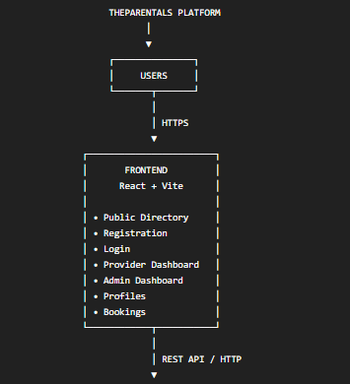
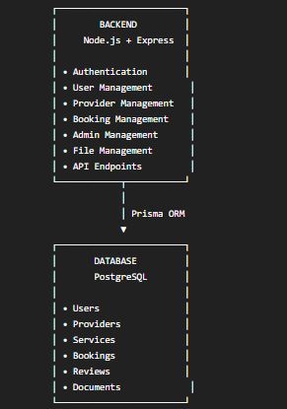
8.2 Frontend Architecture

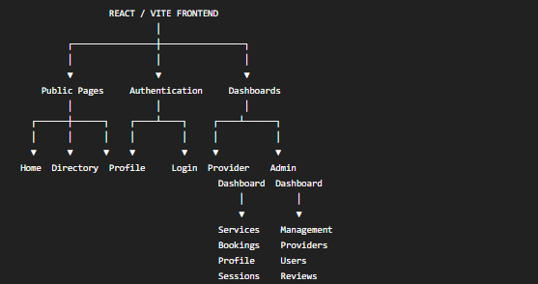

The frontend is responsible for:
- rendering the user interface
- navigation
- forms
- client-side validation
- displaying API data
- managing dashboard views
- communicating with the backend
- providing responsive layouts

8.3 Backend Architecture

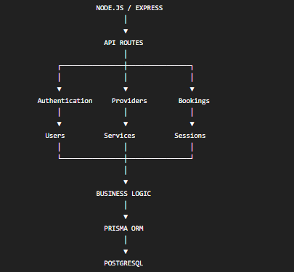

The backend acts as the central communication layer between the frontend and database.

8.4 Database Architecture

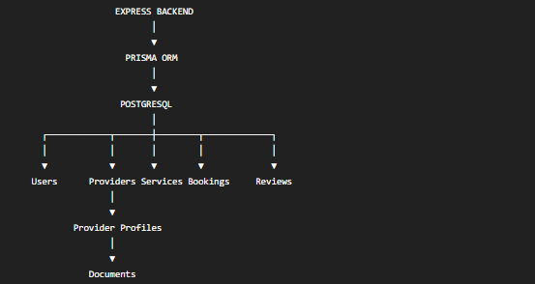

The database provides persistent storage for the platform's core business data.

8.5 Authentication Architecture
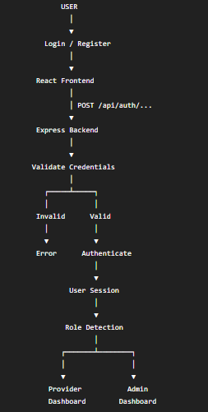

8.6 Provider Registration Flow

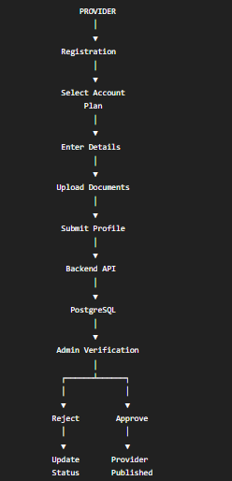

8.7 Public Directory Flow

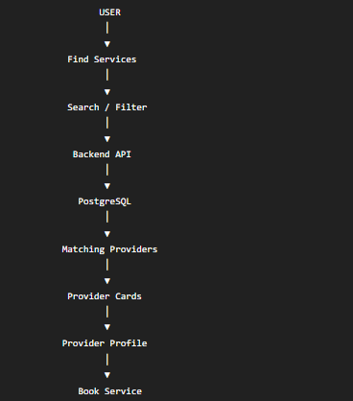

8.8 Booking Flow
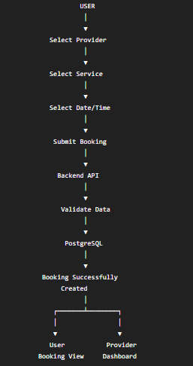

8.9 Admin Architecture

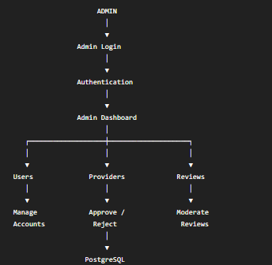

8.10 Complete System Flow Diagram
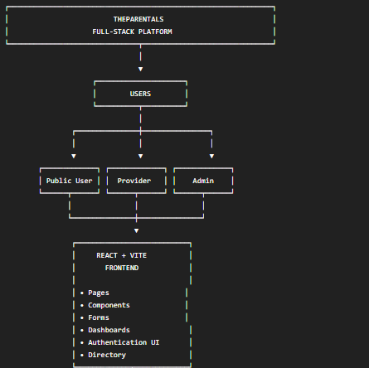
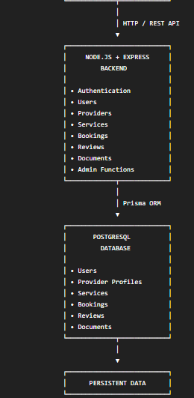

8.11 External Services and Integrations

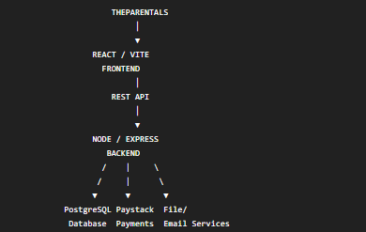

This keeps the architecture accurate: the frontend talks to the backend, the backend handles business logic, Prisma communicates with PostgreSQL, and external services are accessed through the appropriate backend/API integration.

